Stage 3 Physics:
Particles, Waves and Quanta Student Workbook Two
Outcomes 12 to 16

Name: TEACHER’S GUIDE

The outcomes in this workbook should take about 10 hours of class time. The main points are briefly covered in this workbook but students will need to do their own research using the Internet to expand these points.

Description:
The unit content organisers are particles, waves and quanta and motion and forces in electric and magnetic fields. Study of mechanical and electromagnetic waves allows students to extend their understanding of the nature and behaviour of waves. They analyse spectra and explain a range of physical phenomena such as fluorescence and X-ray emission. They also learn about some topics of modern physics such as relativity and cosmology.

Contexts:

Within the unit content organisers of particles, waves and quanta and motion and forces in electric and magnetic fields, teachers must present the unit content through one or more contexts, such as the following (this list is not exhaustive):

Student unit learning contexts for particles, waves and quanta may include:
- medical imaging and therapies
- colours of fireworks
- sunlight and starlight
- sonar and echo-location
- optical fibres
- musical instruments
- communication systems
- security/remote sensing systems.
Working in physics
Students research and report on a question relating to a real world problem. They develop problem-solving strategies that involve linking a number of concepts and principles. They consider the level of absolute and percentage uncertainty in experimental measurements and conclusions. This includes the use of error bars when displaying data and conclusions graphically.

Plan For Unit.
This workbook will give you an outline of the content to be covered and the related text pages. It is not intended to be used alone but in conjunction with your text and teacher. It is expected that you will follow the workbook and read the related text, experiments and investigations before the lesson. It will be assumed that you have read the text and have some introductory knowledge of the work to be covered each lesson; failure to do so may affect your progress in class. Your teacher will then teach you the concepts and show you how to do the examples in the workbook thus ensuring you have exemplars when completing additional questions from the workbook and texts. Your teacher also has all the worked answers to the additional questions in this workbook and you must check your answers when you complete the questions.

In addition to the work set for homework, it is essential that you set up a study plan and regularly review the work covered. This plan should be set up from day one. Regular reviewing not only makes study easy, it ensures good grades.
Week | Content | Exploring Physics |  | Assessments
Week | Content | Possible Problem Sets | Possible Experiments & Investigations | Assessments
8 | Review Examination  Particles, waves and quanta  - explain and apply the concepts of amplitude, frequency, wavelength, displacement and speed of longitudinal and transverse mechanical waves—including applying the relationships: 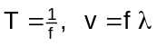 | Set 9: Waves | Expt: 9.1  Expt: 9.2  Expt: 10.1 | Task 2: Validation of research topic e.g. make a mind map of your research in class.  Topic: e.g.  Receiving and transmitting antennas
9 | - explain and apply the concepts of reflection, refraction and diffraction of wave fronts  - explain and apply the concepts of free oscillations, forced oscillations, interference and standing waves—this will include identifying nodes and antinodes, using the expression internodal distance = ½ λ  - sketch diagrams to illustrate the behaviour of waves in a variety of situations | Set 10: Wave Behaviour | Expt: 10.2  Expt: 10.3  Possible:  Expt: 10.4  Expt: 10.5
10-11 | - describe and explain the nature and properties of electromagnetic waves, including the concept of light as a wave of changing electric and magnetic fields, and its wave and particle properties  - describe and apply electromagnetic radiation and the emr spectrum  - classify emr spectra as emission spectra and absorption spectra and as line, broadband and continuous spectra  - describe and explain how astronomical observations exploit differences in properties of the various parts of the emr spectrum in order to gather more information about celestial bodies | Set 11: Photons | Expt: 11.1  Expt: 11.2  (demo)  Expt: 11.3  (demo)
Term 3 Particles, waves and quanta continue
1 | - explain and interpret line emission spectra, line absorption spectra and ionisation using the Bohr model of the atom and the concepts of ground and excited states, photons, quanta and energy level transitions—this includes applying the relationships: c = fλ, E = hg, E₂ – E₁ = hf  - explain fluorescence and the generation of X-rays—this includes applying the relationships: 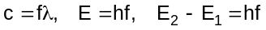 | Set 12: Atoms and X-rays | Expt: 12.1  Expt: 12.2  Invest: 12.3  Invest: 12.4  (home research)
2-3 | Workbook Two  - extend concept of subatomic particle to include neutrinos and quarks  - describe the qualitative aspects of the special theory of relativity such as reference frames and the mass-energy equivalence principle  - apply the speed of light in vacuum to astronomical distances to predict and explain transit times of light and particles travelling between planets, stars and galaxies—this will include applying the relationship: 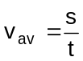  - describe and explain the expansion of the Universe and Hubble’s law  - describe and explain fundamental cosmological concepts such as red shift, the Big Bang Theory and the history and future of the Universe  - describe and explain the importance of particles, waves and quanta in everyday life. | Set 13: charged Particles in Electric Fields | Expt: 13.1  (demo)  Expt 13.2  (demo)  Invest: 13.3  (home research) | Task 9: Test Particles, waves and quanta
Assessment outline: Stage 3 PHYSICS
Outcome 01: Investigating and Communicating in Physics;
Outcome 02: Energy;
Outcome 03: Forces and Fields

Assessment type | Assessment type weightings | Tasks | Content | Outcomes coverage |  |  | Weighting  %
 |  |  |  | O1 | O2 | O3 | 3A | 3B | Total
Experiments and investigations  (20-40%) | 21% | Task 1: Practical exam (3A) | Practical exam on 3A experiments and investigations |  |  |  | 5 |  | 5
Experiments and investigations  (20-40%) | 21% | Task 2: Research topic | Validation activity on student research (written report) |  |  |  |  | 3 | 3
Experiments and investigations  (20-40%) | 21% | Task 3: Extended Investigation | Extended investigation |  |  |  | 4 | 4 | 8
Experiments and investigations  (20-40%) | 21% | Task 4: Practical exam (3B) | Practical exam on 3B experiments and investigations |  |  |  |  | 5 | 5
Tests and Examinations  (60-80%) | 79% | Task 5:Validation tests on Assignments, Problem Sets and Homework | Accumulation of validation tests on Assignments, Problem Sets and homework |  |  |  | 2 | 2 | 4
Tests and Examinations  (60-80%) | 79% | Task 6: Test Projectile Motion | Test on projectile motion |  |  |  | 3 |  | 3
Tests and Examinations  (60-80%) | 79% | Task 7: Test Motion and forces in a gravitational field | Test on Motion and forces in gravitation al field |  |  |  | 4 |  | 4
Tests and Examinations  (60-80%) | 79% | Task 8: Test electricity and magnetism | Test on Electricity and Magnetism unit |  |  |  | 6 |  | 6
Tests and Examinations  (60-80%) | 79% | Task 9: Test Particles, waves and quanta | Test on Particles, waves and quanta unit |  |  |  |  | 6 | 6
Tests and Examinations  (60-80%) | 79% | Task 10: Test Motion and Forces in Electric and Magnetic Field | Test on Motion and Forces in Electric and Magnetic Field unit |  |  |  |  | 6 | 6
Tests and Examinations  (60-80%) | 79% | Task 11: Semester One Examination | Examination on 3A |  |  |  | 20 |  | 20
Tests and Examinations  (60-80%) | 79% | Task 12:Stage 3 Examination (includes 20% of 3A) | Examination on Stage 3 work |  |  |  | 5 | 25 | 30
TOTALS |  |  |  |  |  |  | 50 | 50 | 100

NOTE:

The information contained in this workbook is only a brief summary of the concepts and it is strongly recommended that students use a number of resources in studying this section of work. For example the WACE Study Guide 3A & 3B Physics by Michael Lucarelli, your text book and information gained from research on the Internet.

Outcome 12 (Students should spend about 2 hours on this concept including website searches.)
Describe the qualitative aspects of the special theory of relativity such as reference frames and the mass-energy equivalence principle.

Principle of Relativity and Galileo

Consider the example of a person running backwards on a train at the same speed the train is moving forward, say at 5.0 m s⁻¹. Two people observe this runner each from their own frame of reference. Person A is standing at the front of the train watching the runner move away from them at 5.0 m s⁻¹. Person B however, is standing on a platform watching the train go by and to him the runner is not moving. The motion of the runner is relative to the position of the observer; to their own different frame of reference.

Relativity began with Galileo, who said that, in the laws of mechanics, only relative motion is important. In other words, mechanical forces are the same for the person on the train and the platform. They simply need to add or subtract the relative velocities to convert their measurements and then obtain the same mechanical forces. The website below has an animation to demonstrate frames of reference.
http://www.phys.unsw.edu.au/einsteinlight/jw/module1_Galileo_and_Newton.htm

Einstein’s Special Theory Of Relativity

Einstein's Special Theory of Relativity describes the motion of particles moving at close to the speed of light. In fact, it gives the correct laws of motion for any particle. This doesn't mean Newton was wrong, his equations are contained within equations relating to relativity. Newton's "laws" provide a very good approximate form, valid when v is much less than c.

For particles moving at slow speeds (very much less than the speed of light), the differences between Einstein's laws of motion and those derived by Newton are tiny. That's why relativity doesn't play a large role in everyday life. Einstein's theory supersedes Newton's, but Newton's theory provides a very good approximation for objects moving at everyday speeds and hence their use in physics in senior schooling.

Theoretical Basis for Special Relativity

The first postulate states that the speed of light is the same for all observers, no matter what their relative speeds. The speed of light will be seen to be the same relative to any observer and therefore independent of the motion of the observer. This is the crucial idea that led Einstein to formulate his theory. It means we can define a quantity c, the speed of light, which is a fundamental constant of nature.

Note that this is quite different from the motion of ordinary, massive objects. Imagine you are driving down the freeway at 90 kilometres per hour relative to the road, a car travelling in the same direction at 100 km h⁻¹ has a speed of only 10 km h⁻¹ relative to you, while a car coming in the opposite direction at 100 km h⁻¹ approaches you at a rate of 190 km h⁻¹ . Their speed relative to you depends on your motion as well as on theirs.

The second postulate states that the laws of physics are the same in any inertial (that is, non-accelerated) frame of reference. This means that the laws of physics observed by a hypothetical observer travelling with a relativistic particle must be the same as those observed by an observer who is stationary.

This second postulate is really a basic though unspoken assumption in all of science. It is the idea that we can formulate rules of nature which do not depend on our particular observing situation. This does not mean that things behave in the same way on the earth and in space, for example an observer at the surface of the earth is affected by the earth's gravity, but it does mean that the effect of a force on an object is the same independent of what causes the force and also of where the object is or what its speed is.

Consequences of the Special Theory of Relativity

Einstein said that all of the consequences of special relativity can be derived from examination of the Lorentz transformations. These transformations, and hence special relativity, lead to different physical predictions than that of Newtonian mechanics. These transformations occur when relative velocities become comparable to the speed of light.

- Time dilation: The time lapse between two events can change from one observer to another and is dependent on the relative speeds of the observers' reference frames (e.g., the twin paradox which concerns a twin who flies off in a spaceship travelling near the speed of light and returns to discover that his or her twin sibling has aged much more).

- Relativity of simultaneity: Two events happening in two different locations that occur simultaneously in the reference frame of one inertial observer, may not occur simultaneously in the reference frame of another inertial observer (lack of absolute simultaneity).

- Lorentz contraction: The dimensions (e.g., length) of an object as measured by one observer may be smaller than the results of measurements of the same object made by another observer (e.g., the ladder paradox involves a long ladder travelling near the speed of light and being contained within a smaller garage).

- Composition of velocities: Velocities (and speeds) do not simply 'add', for example if a rocket is moving at  the speed of light relative to an observer, and the rocket fires a missile at  of the speed of light relative to the rocket, the missile does not exceed the speed of light relative to the observer.

- Inertia and momentum: As an object's speed approaches the speed of light from an observer's point of view, its mass appears to increase thereby making it more and more difficult to accelerate it from within the observer's frame of reference.

- Equivalence of mass and energy, E = mc² : The energy content of an object at rest with mass m equals mc² (c = speed of light). Conservation of energy implies that in any reaction a decrease of the sum of the masses of particles must be accompanied by an increase in kinetic energies of the particles after the reaction. Similarly, the mass of an object can be increased by taking in kinetic energies and therefore goes faster.

Speed of Light

No object with mass can accelerate to precisely the speed of light. A massless object, like a photon, can move at the speed of light. (A photon doesn't actually accelerate, though, since it always moves exactly at the speed of light.)

But for a physical object, the speed of light is a limit. The kinetic energy at the speed of light goes to infinity, so it can never be reached by acceleration.

Some have pointed out that an object could in theory move at greater than the speed of light, so long as it did not accelerate to reach that speed. However, so far no physical entities have ever displayed that property.

Websites to Work Through:
Work through the following websites to further enhance your understanding of this section.
http://www.phys.unsw.edu.au/einsteinlight/
http://www.anu.edu.au/Physics/Savage/TEE/site/tee/learn.html
http://www.teachersdomain.org/resource/phy03.sci.phys.energy.sprelativity/
http://www.youtube.com/watch?v=AZ6N85lNgHY
http://www.squidoo.com/relativity_explanation

Outcome 13 (Students should spend about 1 hour on this concept including website searches.)
Apply the speed of light in vacuum to astronomical distances to predict and explain transit times of light and particles travelling between planets, stars and galaxies—this will include applying the relationship: .

Units of Light

- Light year: A light year is the distance travelled by light in one year which is exactly 460,730,472,580.8 km. It is based on exactly 365.25 days each with exactly 86,400 seconds (31,557,600 seconds in total) and defined as the speed of light of exactly 299,792,458 m s⁻¹.
For ease of calculations, one light year = 9.46 x 10¹⁵ m as shown below.
s = vt
= 299 792 458 x 365.24 x 86 400
= 9.46 x 10¹⁵ m or 9.46 x 10¹² km

- A Light minute is the time light will travel in one minutes while a light hour is the time light travels in one hour. Using the ideas above, you can calculate the distance travelled by a light minute and a light hour. The light month is not precise so is not used.

- Parsec: A parsec (pc) is a unit of length used in astronomy equal to about 10¹² km or about 3.26 light years. A megaparsec is 10¹⁸ km which is the common unit for measuring distances between galaxies. For example, the Andromeda Galaxy is 0.77 Mpc from the Earth.

Practical: Parallax investigation
http://www.ifa.hawaii.edu/users/mickey/ASTR110L_S05/parallax.html

Calculations using the speed of light

The distance to Alpha Centaui A & B is roughly 4.35 light years. Calculate this in kilometres and parsecs.

Kilometres: 1 light year = 9.46 x 10¹² km
distance to Alpha Centaui = 9.46 x 10¹² x 4.35
= 4.12 x 10¹³ km

parsecs: 1 pc = 3.26 light years
distance = 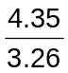
= 1.33 pc

Observing the past

Light may seem to travel fast at 3 x 10⁸ m s⁻¹ but when looking at objects in the sky, say the Andromeda Galaxy which is about 2 x 10¹⁸ km away, that is a long distance for light to travel to our eyes. In fact, light takes about a second to get to the moon and back. That slow crawl of light across the universe means that what you're seeing when you look at starts is light that left them many years ago. Therefore when we look at objects really far away, we are actually looking back in time. For example, it takes the Sun’s light eight minutes to reach us. When we look at the sun, we are looking at it as if it was eight minutes ago. That means if the sun suddenly disappeared, we wouldn't know it for eight minutes.
A star called Betelgeuse (see picture next page) is about 600 light years away. Astronomers expect it to go supernova soon. But it could have actually exploded a long time ago, and the light just hasn't reach us yet. So when we look 13 billion light years away, we are looking back in time almost to the creation of the universe and the Big bang. So the farther away an object is, the longer it takes light to get here and the farther back in time we are seeing.
Scale of solar system, interstellar scales (stellar parallax), Universe
The distance to other planets in our solar system, to other stars and beyond our galaxy is almost unimaginable. Watch this youtube animation to get some idea and look at the pictures below.
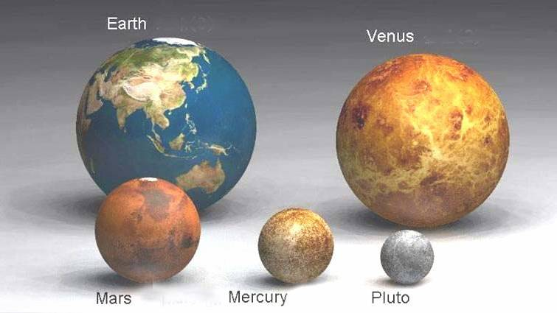
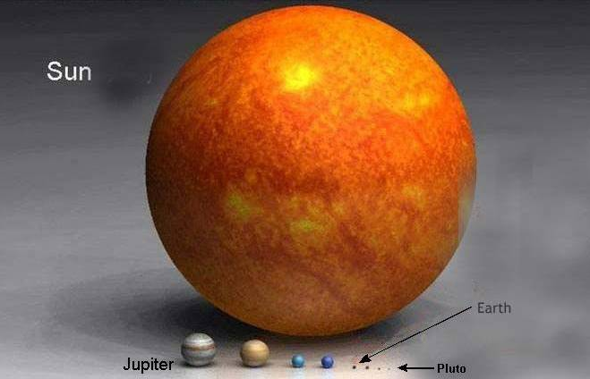
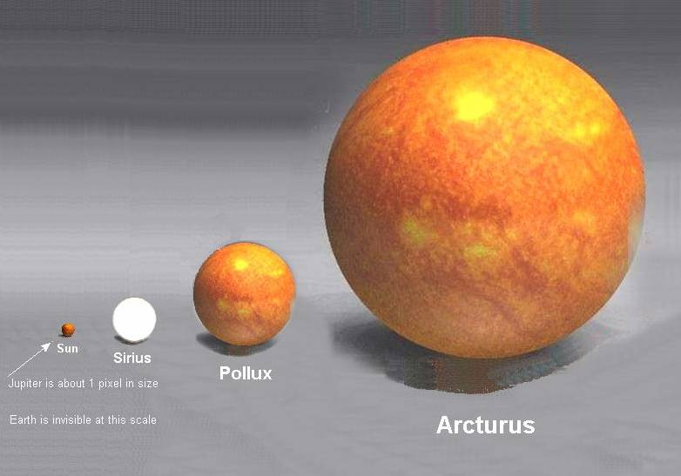
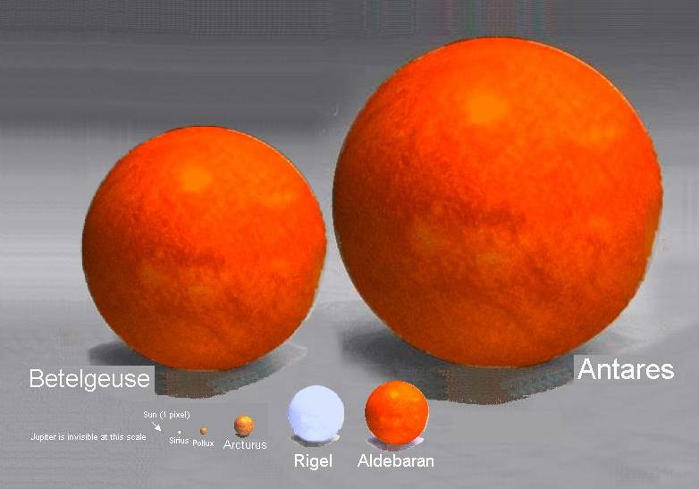
http://www.youtube.com/watch?v=aPm3QVKlBJg
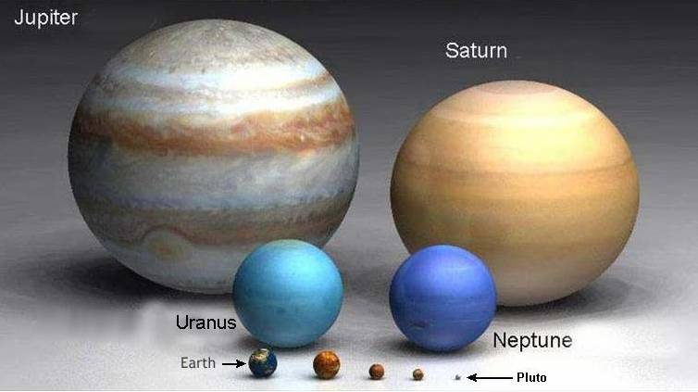
Antares is the 15th brightest star in the sky. It is more than 1000 light years away.
As you can see, beyond our sun it's a big universe.
Outcome 14 and 15
Describe and explain the expansion of the universe and Hubble’s law.
Describe and explain fundamental cosmological concepts such as red shift, the big bang theory and the history and future of the universe.

Wave Theory of Light

Light is both wave-like and particle-like in nature, hence it has a duel nature
Particles travel in wave-like motion. Work by Huygens (1629 – 1695) showed wave-like properties (reflection, refraction, diffraction). Wave-like properties also shown by work of Thomas Young (double slit experiment) which showed interference patterns producing light and dark areas on screen. As wave-like, can use wave formula in calculations; v = fλ
Doppler effect.

You probably have at some time observed the Doppler Effect. A car sounding its horn as it passes is an example of this phenomenon. As the car passes by, the pitch of the horn drops significantly – sometimes as much as two whole notes on the musical scale. Waiting at a level crossing in a car, you will also notice the Doppler Effect in action. The whistle on a fast moving train sounds markedly higher as the train approaches a level crossing than it does as the train is receding.

The relative motions of the sound sources and the observer are responsible for the change in pitch of the sounds in the examples cited above. To explain the Doppler Effect, consider the following example. When a horn on a car is blown, it emits longitudinal waves that travel in all direction. These spherical waves move with the same velocity and have the same frequency. To all stationary observers, no matter where they are located, the true frequency or pitch of the horn is heard. This occurs because the waves reaching the ears of any stationary person listening to the sound are the same frequency as the source, in this case, the horn.
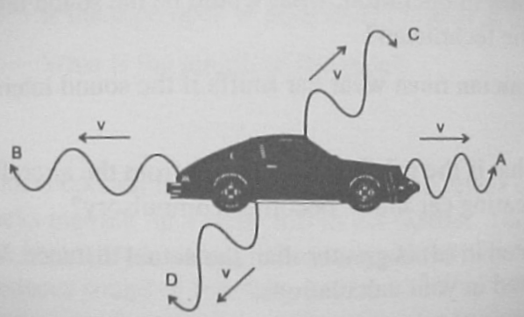
The diagram shows the effect a moving sound source has on the sound waves being produced by the horn. The horn is actually moving towards the waves travelling forward and away from the waves travelling to the rear of the car. The waves leaving the back of the car are therefore more drawn out whilst those waves travelling forward are closer together. As the horn continues to produce sound waves, an observer at A will hear more waves per second than an observer at B (The velocity of sound is the same in all direction).

The pitch of the horn on a fast moving car sounds higher to an observer in front of the car, lower to an observer behind, and normal to observers off the sides, (C and D)

The general relationship between velocity and frequency for the Doppler Effect is given by the following single equation:
where: f_{s} = frequency of the source (Hz)
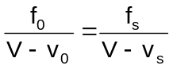 f₀ = frequency heard by observer (Hz)
V = velocity of sound (m s⁻¹)
v_{s} = velocity of source (m s⁻¹)
v₀ = velocity of observer (m s⁻¹)

Since velocity is a vector quantity, consideration must be given to the direction of the waves. The velocity of sound, V, is assigned a positive value and then the following rules apply.

Rule 1: If the source and observer are approaching each other, v_{o} is positive and v_{s} is negative.
Rule 2: If the source and observer are moving in the same direction, v_{s} and v_{o} are both positive.
Rule 3: If the observer is at rest and the source is approaching at a velocity v_{s} = 2V (twice the speed of sound or approx. 680 ms⁻¹). Here v_{o} = 0 and v_{s} is positive.
Rule 3 has special significance. As v_{o} is opposite to v_{s}, the observer hears the sound in reverse, i.e., if someone was talking the observer would hear the words backwards!
Red Shift
The Doppler Effect also works with light. According to the Doppler effect for light, the following relationship occurs:
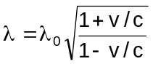
Where λ = the wavelength observed by an observer in a reference frame moving with velocity v and λ₀ = the emitted wavelength as recorded by an observer in the reference frame of the source.

When the source is moving away from the Earth we see a longer wavelength and the colour is shifted towards the red – hence the name red shift. If the source is moving towards us, then the colour of the emitted radiation shifts towards the blue. As the shift in the spectra of very distance galaxies is towards longer wavelengths, that is, towards the red end of the spectrum, this is generally interpreted as evidence that the universe is expanding.

Hubble diagram linking redshift velocities to distance
When Hubble plotted the redshift vs. the distance of the galaxies, he found a surprising relation: more distant galaxies are moving faster away from us. Hubble concluded that the fainter and smaller the galaxy, the more distant it is, and the faster it is moving away from us, or that the recessional velocity of a galaxy is proportional to its distance from us.

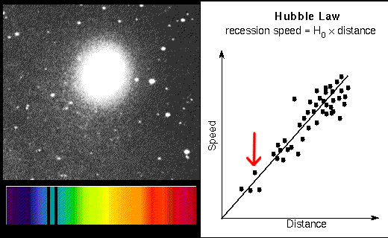

This animation can be seen at:
http://www.scriptphd.com/?p=659

Hubble’s law: (Calculations not required for the WACE Examination.)

Hubble’s law is the constant of proportionality in the relation between the velocities of remote galaxies and their distances. It shows the rate at which the universe is expanding. Denoted by the symbol, H₀, it is named in honour of Edwin Hubble, the American astronomer who attempted to 1929 to measure its value.

v = H₀D, with H₀ the constant of proportionality (the Hubble constant) between the distance D to a galaxy and its velocity v. The SI unit of H₀ is s⁻¹ but it is most frequently quoted in (km s⁻¹)/Mpc, thus giving the speed in km s⁻¹ of a galaxy one Megaparsec away. The reciprocal of H₀ is the Hubble time.

Big Bang Theory

The Big Bang Theory is the idea of an explosion of an extremely small, hot, and dense body of matter that, according to some cosmological theories, gave rise to the universe between 12 and 20 billion years ago.

In the 1920s astronomer Edwin Hubble discovered that wherever one looked in space, distant galaxies were rapidly moving away from Earth, and the more distant the galaxy the greater its speed. Through this observation he determined that the universe was becoming larger. Hubble also found that the ratio between a galaxy's distance and velocity (speed and direction of travel) was constant; this value is called the Hubble constant.

By calculating the distance and velocity of various galaxies and working backward, astronomers could determine how long ago the expansion began in other words, the age of the universe. The figure, which scientists are constantly refining, is currently thought to be between 12 and 20 billion years (the latest is about 13.7 ± 0.13 billon years). According to the widely accepted theory of the big bang, the universe was originally smaller than a dime and almost infinitely dense. A massive explosion, which kicked off the expansion, was the origin of all known space, matter, energy, and time. Scientists are also attempting to calculate how much mass the universe contains in order to predict its future. If there is enough mass, the gravity attracting all its pieces to each other will eventually stop the expansion and pull the universe back together in a big crunch. There may not be enough mass, however, to result in an eventual collapse. If that is the case, then the universe will expand forever, and all galaxies and matter will drift apart, eventually becoming dark and cold.

Future of the Universe
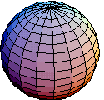
Closed Universe
One model of the universe is the closed universe in which the curvature of space is roughly spherical, this then implies that the universe has finite size. An object moving in a straight line in a closed universe would eventually return to its starting point. According to most current cosmological theories, the universe is closed if it is sufficiently dense, and therefore possesses enough gravitational force to stop or reverse the expansion started by the big bang (resulting in what is called the big crunch).

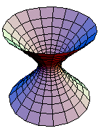
Open Universe
Another model of the universe is the open model in which the curvature of space is flat or curved away from itself, this then implies that the size of the universe is infinite. According to this model, gravity between objects is not able to stop or reverse the expansion of the universe, thus objects continue to move farther and farther apart as space moves outward. An object moving in a straight line in an open universe would never return to its starting point. According to current cosmological theories, the universe is open if it is insufficiently dense. Such a universe will never end, but will eventually become very cold and dark because stars gradually lose all of their energy. Compare closed universe.
Outcome 16
Describe and explain the importance of particles, waves and quanta in everyday life.

Many natural phenomena, which are part of our everyday life, relate to particles, waves and quanta. Below is a series of questions that you are to research and use your understanding of particles, waves and quanta, to explain.

- Most of us have been to the Royal Show at least once in our lives. At the end of the night they have a firework display and we all love the colours on display. Using your understanding of wavelengths and spectra, explain how we could develop a scientific method for quantifying fireworks.

Each colour in the firework corresponds to a range of wavelengths. Wavelength and intensity of the spectra are both quantitative quantities which can be measured by spectroscopy and be represented as a graph of intensity vs wavelength.
___________________________________________________________________________
___________________________________________________________________________
___________________________________________________________________________
___________________________________________________________________________
___________________________________________________________________________
___________________________________________________________________________
- Use your understanding of diffraction to explain the twinkling of stars and then explain why stars seen from the Hubble telescope don’t twinkle.

The refraction of the light of a star through layers of Earth’s atmosphere cause the twinkling of stars. The light from the star bens differently in different densities of the atmosphere. Generally, as the stars closer to the horizon have to travel through more layers of the air, they will twinkle more. Out in space however the stars do not twinkle and this has been shown by the Hubble telescope.
___________________________________________________________________________
___________________________________________________________________________
___________________________________________________________________________
___________________________________________________________________________
- Find out what the word LASER stands for and how laser light is different from light from say a torch.

LASER stands for Light Amplification by Stimulated Emission of Radiation. The beam from a LASER light is monochromatic (only one colour), coherent and directional hence its ability to travel much further than say a torch. LASER lights are used in entertainment, communication, imaging and surgery depending on their strength.
___________________________________________________________________________
___________________________________________________________________________
___________________________________________________________________________
___________________________________________________________________________
___________________________________________________________________________

- Many women have an ultrasound images when they are pregnant. What is ultrasound and why is it used in this way?

Ultrasound imaging technique is based on reflection of soundwaves of frequency greater than that of human hearing that is, greater than 20 000 Hz
___________________________________________________________________________
___________________________________________________________________________
___________________________________________________________________________
___________________________________________________________________________
___________________________________________________________________________
___________________________________________________________________________
___________________________________________________________________________

- You often hear about jets flying supersonic. What does the term supersonic mean?

Supersonic refers to sounds which are faster than the speed of sound e.g. above about 346 m s⁻¹
___________________________________________________________________________
___________________________________________________________________________
___________________________________________________________________________
___________________________________________________________________________
___________________________________________________________________________
___________________________________________________________________________
___________________________________________________________________________

- When the doctor suspects you have a broken bone, you have an X-ray. Generally, the number you have is limited. Explain why you need to limit the number of X-ray images you have a year.

X-rays are electromagnetic radiation which have high energy and low wavelengths. They are able to penetrate through the skin so that their energy is absorbed by tissues close to the bone. Excessive exposure to X-rays will cause non-remedial injury to cells and may become cancerous.
___________________________________________________________________________
___________________________________________________________________________
___________________________________________________________________________
___________________________________________________________________________
___________________________________________________________________________

NOTE:
The questions above come from DOT POINT WACE Physics Units 3A and 3B by Brian Shadwick and Atit Bhargava. This is an excellent reference book and well worth buying for your own use or for student use.
- There is a great deal of research into subatomic particles but has it benefited us in our everyday life? Research how the development in our knowledge of subatomic particles may benefit us now and in the future.

No specific answer here as it is intended that the students do their own reseach.
___________________________________________________________________________
___________________________________________________________________________
___________________________________________________________________________
___________________________________________________________________________
___________________________________________________________________________
___________________________________________________________________________
___________________________________________________________________________
___________________________________________________________________________
___________________________________________________________________________
___________________________________________________________________________
___________________________________________________________________________
___________________________________________________________________________
___________________________________________________________________________
___________________________________________________________________________
___________________________________________________________________________
___________________________________________________________________________
___________________________________________________________________________
___________________________________________________________________________

NOTE:

- As this is a new area to be covered in Physics, the Curriculum Council has made available to teachers a range of possible question types and allocated marks.

Students are recommended to work through these questions that follow to enhance their understanding of the types of questions that could be asked in an external examination.

- You may prefer to remove some of these questions to use in assessment tasks.

Curriculum Council Resources: PHYSICS
Assessment Support Materials for Unit 3B:
Astrophysics section of Particles, waves and quanta

Question 1 (7 marks)
- List two characteristics of all electromagnetic waves. (2 marks)
- travel through a vacuum
- absolute maximum velocity of 3x 10⁸ m s⁻¹ (2 marks)

To answer the following parts of question, refer to the electromagnetic spectrum diagram shown below.
 |  | Wavelength
λ (m) |  |  |  |  |  |  |  |  |  | 10² |  |  |  | 10 |  |  |  |  |  | 1 |  |  |  |  |  |  |  |  |  | 10⁻¹ |  |  |  | 10⁻² |  |  |  | 10⁻³ |  |  |  |  |  | 10⁻⁴ |  |  |  | 10⁻⁵ |  |  |  | 10⁻⁶ |  |  |  | 10⁻⁷ |  |  |  |  |  |  |  | 10⁻⁸ |  |  |  |  | 10⁻⁹ |  |  |  |  | 10⁻¹⁰ |  |  |  |  | 10⁻¹¹ |  |  |  |  |  | 10⁻¹²
Area of  spectrum |  |   microwaves  radio frequencies  infrared radiation  ultraviolet  radiation  X-rays  gamma rays
f(Hz) |  |  |  |  |  |  | 10⁶ |  |  |  |  |  | 10⁷ |  |  |  | 10⁸ |  |  |  |  |  |  |  |  |  |  |  | 10⁹ |  |  |  | 10¹⁰ |  |  |  | 10¹¹ |  |  |  |  |  | 10¹² |  |  |  | 10¹³ |  |  |  | 10¹⁴ |  |  |  | 10¹⁵ |  |  |  |  |  |  |  | 10¹⁶ |  |  |  | 10¹⁷ |  |  |  |  |  | 10¹⁸ |  |  |  |  | 10¹⁹ |  |  |  |  |  | 10²⁰
 | Frequency

Note: 1. Shaded areas represent regions of overlap.
2. Gamma rays and X-rays occupy a common region.

- What is the approximate frequency of a short-wave radio wave from the ‘middle’ of the short-wave spectrum? 10⁶ Hz (1 mark)

- Name two types of electromagnetic waves besides visible light that have allowed astronomers to learn more about celestial bodies and the universe. (2 marks)

Infrared and radio waves (2 marks)

- Describe the information that each type of wave mentioned in part (c) provides to astronomers.

Infrared astronomy allows astronomers to view low temperature objects that are not able to be observed in the visible region of the EM spectrum.
Radio astronomy allows astronomers to view objects that are obscured by interstellar dust.
(2 marks)

Question 2 (5 marks)
The Hubble telescope was launched in 1990 and has orbited the Earth since at an average distance of about 570 km above the Earth’s surface.

On the Hubble website, the claim is made that “Hubble is one of NASA’s’ most successful and long-lasting science missions. It has beamed hundred of thousands of images back to Earth, shedding light on many of the great mysteries of astronomy. Its gaze has helped determine the age of the universe, the identity of quasars and the existence of dark energy. “

- Provide three reasons why the Hubble telescope has been so successful compared to larger Earth-based telescopes. (3 marks)

- Able to view infra red wavelengths absorbed by water vapour and carbon dioxide in the earths atmosphere
- Able to make observations of the near-ultraviolet absorbed by the earths atmosphere
- Operates continuously
- Light is not obscured by dust or clouds.
- Light is not subject to atmospheric distortion due to differences in refractive indices.
(3 marks)

- It has been stated that the Hubble telescope allows us to look back in time to billions of years ago. Explain this statement. (2 marks)

The Hubble telescope is able to record images of the universe's most distant objects.
The light that forms these images has taken billions of years to reach the telescope. (2 marks)

Question 3 (4 marks)
The ‘Big Bang’ theory is a model used to explain the origin of the universe. Describe two pieces of scientific evidence which support this theory.

- Redshift
- Abundance of light elements
- Hubble’s law
- Cosmic microwave background radiation

Question 4 (6 marks)
The Big Bang theory predicts that the universe is expanding.

Describe two possible models that have been proposed to explain the behaviour of the expanding universe.

- open—expand for ever
- closed universe—stop expanding and then implode on itself

Question 5 (9 marks)
The Doppler shift in the wavelength of light emitted by galaxies can be used to measure the speed with which they are moving towards or away from the Earth.

Like the Sun, galaxies emit a wide range of wavelengths. The analysis of the absorption spectra of light from galaxies can have two spectral lines missing due to the absorption by calcium ions as light passes through the gases surrounding galaxies.

In the constellation Eridanus which is visible in the western sky between January to April there is a spiral galaxy NGC 1357. The wavelength of one of the calcium absorption lines in the spectrum from NGC 1357 is 399.72 nm. The same line in the calcium spectrum measured in a laboratory on Earth is 396.85 nm.

- Is the spiral galaxy NGC 1357 moving towards or away from the Earth? (1 mark)
The spiral galaxy NGC 1357 is moving away from us.

- Justify your answer to (a) using a brief explanation and a diagram. (4 marks)
The wavelength of the calcium line in the spectrum from NGC 1357 has increased.
This is a characteristic of a source moving away from an observer
(Earth 396.85 nm, NGC 1357 399.72 nm) (2 marks +2 for diagram)

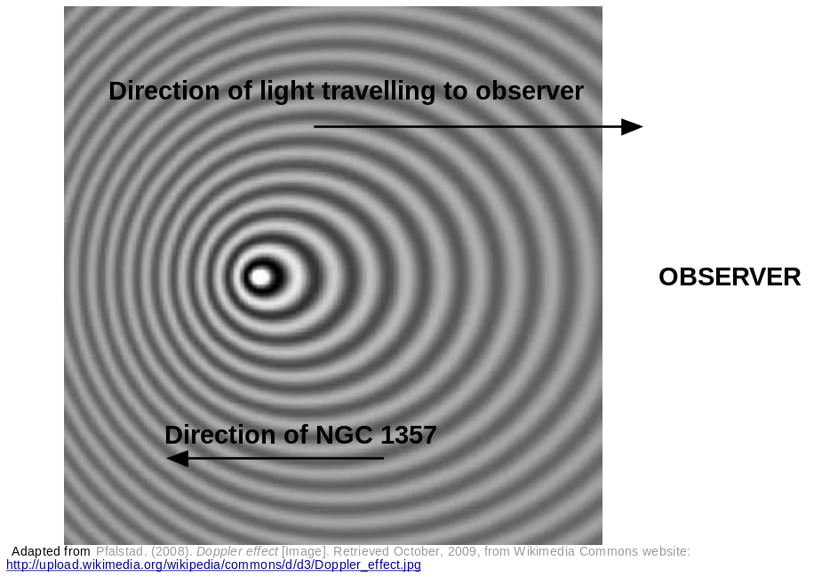

- Calculate the velocity of NGC 1357 using the relationship
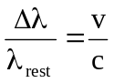
Δλ = λ_{shifted} - λ_{rest}
where and  _{rest} is the wavelength of the fixed source,  is the speed of the moving source and c is the speed of light. (2 marks)

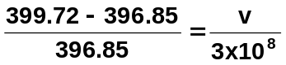

v = 2.169 x 10⁶ m s⁻¹
(2 marks)

- A star has a recessional velocity of 58.9 km s⁻¹. Calculate the ‘red shift’ that would be expected in the calcium 396.849 nm absorption line from this star.
Use the relationship where) is the change in wavelength, _{rest} is the wavelength of the fixed source,  is the speed of the moving source and c is the speed of light. (2 marks)

Use the relationship 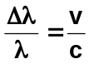
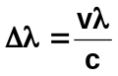

= 58.9 x 1000 x 396.85 x 10⁻⁹
3x 10⁸

= 7.791 x 10⁻¹¹ m = 0.0791 nm
(2 marks)

Question 6 (6 marks)
The Spitzer Space Telescope was launched on August 25, 2003. After more than five-and-a-half years, NASA's Spitzer Space Telescope has run out of the coolant that kept its infrared instruments chilled to -270°C. Since then Spitzer is still making observations but it has warmed to
-240°C.
INCLUDEPICTURE "http://upload.wikimedia.org/wikipedia/commons/thumb/5/58/Sirtf0329_06.jpg/399px-Sirtf0329_06.jpg" \* MERGEFORMAT 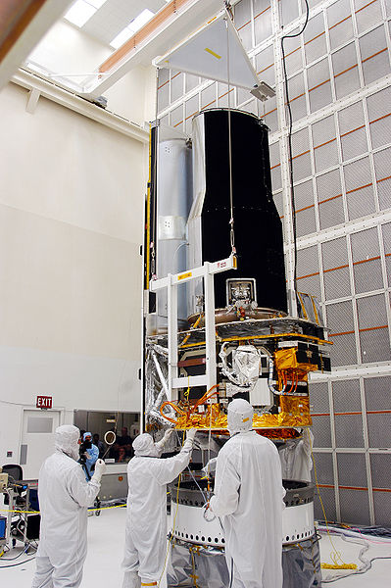
NASA. (2007). Workers at Kennedy Space Center [Photograph]. Retrieved October, 2009, from Wikimedia Commons website: http://upload.wikimedia.org/wikipedia/commons/5/58/Sirtf0329_06.jpg

- Why was it necessary to cool the instruments on the Spitzer Space telescope? (1 mark)
Spitzer telescope views in infrared and must be colder than its surroundings. (1 mark)

- Why is a satellite useful for making infrared observations? (1 mark)

Much of the infrared spectrum from space is absorbed by the Earth’s atmosphere. (1 mark)

- What property of infrared radiation makes it useful for making astronomical observations?
(2 marks)

As a result of the Big Bang, the Universe is expanding. For very fast moving, distant objects the visible spectrum can be Doppler shifted into the infrared. (1 mark)

- What effect would the change in temperature of the satellite have on the wavelengths that the telescope would be able to observe? (1 mark)

The telescope is now observing longer wavelength infrared radiation (1 mark)

Question 7 (2 marks)
The Herschel Space Observatory was launched in May 2009 by the European Space Agency. It is equipped with a 3.5 meter diameter telescope which will perform photometry and spectroscopy in approximately the 55–672 micrometer range.

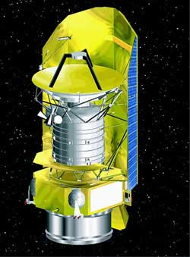
NASA. (2006). Artist's impression of the Herschel Space Observatory [Image]. Retrieved October, 2009, from Wikimedia Commons website: http://upload.wikimedia.org/wikipedia/commons/9/9a/Herschel_Space_Observatory.jpg

 |  | Wavelength
λ (m) |  |  |  |  |  |  |  |  |  | 10² |  |  |  | 10 |  |  |  |  |  | 1 |  |  |  |  |  |  |  |  |  | 10⁻¹ |  |  |  | 10⁻² |  |  |  | 10⁻³ |  |  |  |  |  | 10⁻⁴ |  |  |  | 10⁻⁵ |  |  |  | 10⁻⁶ |  |  |  | 10⁻⁷ |  |  |  |  |  |  |  | 10⁻⁸ |  |  |  |  | 10⁻⁹ |  |  |  |  | 10⁻¹⁰ |  |  |  |  | 10⁻¹¹ |  |  |  |  |  | 10⁻¹²
Area of  spectrum |  | microwaves  radio frequencies  infrared radiation  ultraviolet  radiation  X-rays  gamma rays
f(Hz) |  |  |  |  |  |  | 10⁶ |  |  |  |  |  | 10⁷ |  |  |  | 10⁸ |  |  |  |  |  |  |  |  |  |  |  | 10⁹ |  |  |  | 10¹⁰ |  |  |  | 10¹¹ |  |  |  |  |  | 10¹² |  |  |  | 10¹³ |  |  |  | 10¹⁴ |  |  |  | 10¹⁵ |  |  |  |  |  |  |  | 10¹⁶ |  |  |  | 10¹⁷ |  |  |  |  |  | 10¹⁸ |  |  |  |  | 10¹⁹ |  |  |  |  |  | 10²⁰
 | Frequency

Which part of the electromagnetic spectrum is the telescope observing? (2 marks)

55 micrometer = 55 x 10⁻⁶m or 5.5 x 10⁻⁵m
672 micrometer = 6.72 x 10⁻⁴m (1 mark)
From chart of electromagnetic spectrum – this is in infrared range. (1 mark)

Question 8 (4 marks)
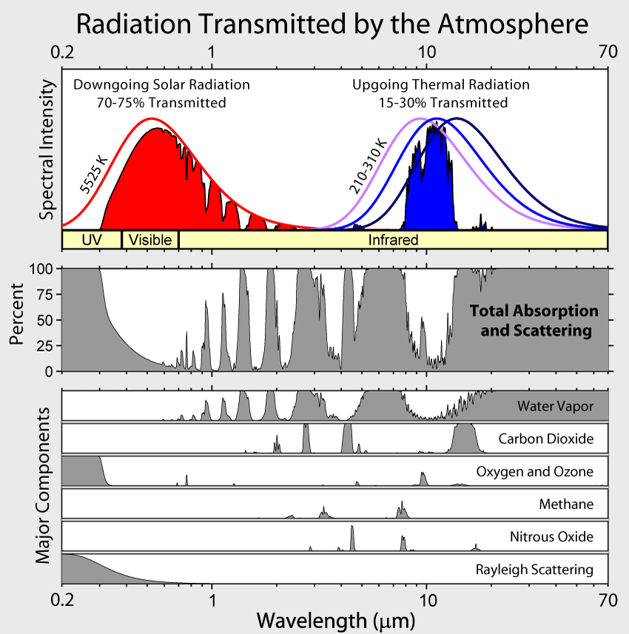
Rohde, R. A. (2007). Radiation transmitted by the atmosphere [Image]. Retrieved October, 2009, from Wikimedia Commons website: http://upload.wikimedia.org/wikipedia/commons/7/7c/Atmospheric_Transmission.png

Using the information in the chart above answer the questions.
- Which wavelengths of radiation from space in the visible and the infrared ranges can be observed from Earth? (2 marks)

Note – wavelength scale is not linear
Visible: 0.4 x 10⁻⁶ m to 0.8 x 10⁻⁶ m (1 mark)

IR: 1.8 x 10⁻⁶ m to 11 x 10⁻⁶ m (1 mark)

- Which compounds in the Earth’s atmosphere interfere with stellar observations in the infrared range? (2 marks)

Water, carbon dioxide (1 mark each)

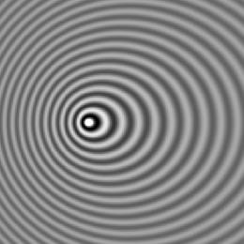
Question 9 (2 marks)
The following photograph is of a vibration pattern produced by a moving object in a ripple tank.

Pfalstad. (2008). Doppler effect [Image]. Retrieved October, 2009, from Wikimedia Commons website: http://upload.wikimedia.org/wikipedia/commons/d/d3/Doppler_effect.jpg

- Which direction is the vibrating source moving towards (left/right/up/down)? left of picture
- Explain your answer. (1 mark)

Waves are closer together on left resulting in higher frequency as predicted by the Doppler effect. (1 mark)

Question 10 (4 marks)
An emergency services vehicle approaches an intersection at 110 km h⁻¹ sounding the horn continuously. The horn has a frequency of 750 Hz. A pedestrian on the footpath at the intersection hears the horn of the approaching at a different frequency.

- Explain what the pedestrian would hear. (1 mark)
Since the source of sound is moving toward the observer it would be at higher frequency.
(1 mark)

- The observed frequency can be calculated using the formula:
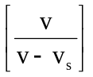
frequency observed = true frequency x

where v is the speed of sound in the medium, v_{s} is the velocity of the moving source.
As the driver approaches the intersection, in the equation is the sign allocated to the velocity of the source + or – to match what the observer hears? Explain your choice. (2 marks)

Must be negative for the denominator to be smaller, to result in a higher value for the frequency. (2 marks)

- Calculate the frequency of the sound heard by the pedestrian. (2 marks)

110 km h⁻¹ = 30.56 m s⁻¹
(1 mark)
Observed frequency = 750 x 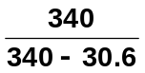 = 824 Hz
(1 mark)

Question 11 (11 marks)
The visible emission spectrum of a hydrogen atom has three bright lines – red, blue-green, and violet. The blue-green line is caused by the emission of a photon as it moves from energy level 4 to energy level 2. The energy of each level (in eV) can be calculated using the formula
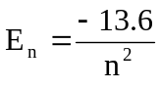

- What is the energy of the photon emitted (in eV) that causes the blue-green line? (1 mark)

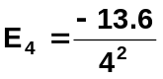 = -0.85 eV 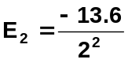= -3.4 eV

E_{4→2} = 3.4 – 0.85 = 2.55 eV
(1 mark)

- What is the wavelength of this line in nanometres? (3 marks)

2.55 ev = 2.55 x 1.6 x 10 ⁻¹⁹ = 4.08 x 10⁻¹⁹ J
(1 mark)
E = hc 4.08 x 10⁻¹⁹ = 6.63 x 10⁻³⁴ x 3 x 10⁸
λ λ
(1 mark)
λ = 7.8 x 10⁻⁷ m
(1 mark)
= 780 nm
(1 mark)

- The blue-green line of the hydrogen spectrum from a close galaxy is observed at 537.4 nm. The redshift Z can be calculated 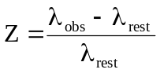

Calculate the red shift of the galaxy. (1 mark)

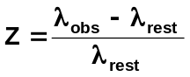 = 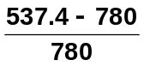 = 0.311
(1 mark)

- For close galaxies receding at a relatively low velocity, the recessional velocity of the galaxy can be calculated from 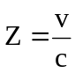 where c is the speed of light.
Use the value of the redshift from (c) to calculate the recessional velocity of the galaxy.(in
km s⁻¹). (2 marks)

Z =  0.311 = 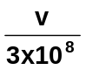
(1 mark)
v = 9.33 x 10⁷ m s⁻¹

= 9.33 x 10⁴ km s⁻¹

- Using Hubble’s law calculate the distance in light-years to this relatively close galaxy using the
redshift value from part (c). (1megaparsec = 3261636.26 light-years)

Hubble’s law: v = H₀ D

v is the velocity (in km s¹), D is the distance ( megaparsecs Mpc ), H₀ is Hubble’s constant
[ H₀ = 74.2 ± 3.6 (km s⁻¹ Mpc⁻¹) ]. (4 marks)

v = H₀ D

9.33 x 10⁴ = 74.2 + 3.6 x D

D = 9.33 x 10⁴
74.2 + 4.85%
(1 mark)
= 1.257 x 10³ Mpc + 4.85%
(1 mark)
= 1.257 x 10⁹ pc + 4.85%

= 4.10 x 10⁹ ly + 4.85%
(1 mark)
= 4.10 x 10⁹ + 2.0 x 10⁸ ly
(1 mark)

Question 12 (3 marks)
Radio telescopes make observations in the 21 cm radio wavelength band. These radio waves are generated by a neutral hydrogen atom. An electron in energy level 1 normally is spinning in the same direction as the proton. If the electron changes to spin in an opposite direction to the proton, a small amount of energy is released resulting in the 21.106 cm radio emission.

What amount of energy is released (in eV) as an electron changes the direction in which it spins on its axis?

E = hf = hc = 6.63 x 10⁻³⁴ x 3 x 10⁸
λ 0.21106
(1 mark)
= 9.42 x 10⁻²⁵J
(1 mark)
In eV = 9.42 x 10⁻²⁵J = 5.89 x 10⁻⁶ eV
1.6 x 10⁻¹⁹
(1 mark)

Question 13 (2 marks)
In 1817 Joseph Fraunhofer examined the spectrum from the Sun. He observed a series of dark lines in the otherwise continuous white light spectrum.

- How are the dark lines produced? (1 mark)

The dark lines are caused by absorption of part of the white light from the Sun’s surface as it passes through gases in the Sun’s atmosphere.

- What information about the sun can be gained from these dark lines? (1 mark)

The pattern of lines identifies the elements in the Sun’s atmosphere.

Question 14 (3 marks)
Georges Lemaître (professor of Physics at University of Leuven in 1927) proposed a theory of the nature of the Universe (now known as the ‘Big Bang’ theory), as a logical extension of Einstein’s General Theory of Relativity. ‘Big Bang’ was not Lemaître’s name – this was coined by astronomers who scoffed at the idea. Astronomers now accept Lemaître’s theory as correct. What evidence has been discovered to support this theory?

1.Expanding universe – further galaxies are moving away faster than closer galaxies. This is
consistent with an explosion – the particles that travel furthest move fastest.
(1 mark)

2. Hubble discovered distances to galaxies are proportional to their redshifts.
(1 mark)

3. Cosmic microwave background radiation is almost uniform in all directions.
(1 mark)

Question 15 (3 marks)
In 1990 NASA launched the Hubble Space telescope despite knowing of a major defect in its 2.4 m reflecting mirror. The telescope was launched on the very last Saturn 5 rocket capable of carrying the telescope into orbit. In 1993 a Space Shuttle mission replaced the mirror allowing Hubble to function correctly. On Earth the largest (Keck) telescopes have a 10 m diameter mirror and are 4100 m above sea level on a dormant volcano.

- Why are telescopes built so far above sea level? (1 mark)

Telescopes high in the mountains look through less of Earth’s atmosphere.

- Why did NASA put the Hubble telescope into space when bigger telescopes exist on Earth?
(2 marks)

Hubble telescope suffers no effects from air distorting the images.
(1 mark)

Hubble also views in infrared range which is not really possible from Earth due to absorption of IR by water in Earth’s atmosphere.

Question 16 (2 marks)

This graph represents the energy intensity released versus wavelength for a “black body”. How can this graph be used to estimate the surface temperature of a star?

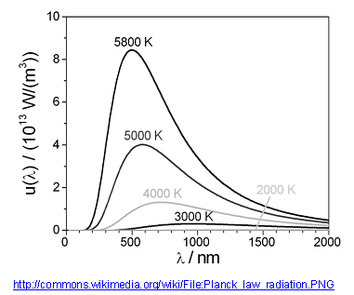

Hubble telescope suffers no effects from air distorting the images.
(1 mark)

Hubble also views in infrared range which is not really possible from Earth due to absorption of IR by water in Earth’s atmosphere.
(1 mark)

Question 17 (4 marks)

The surface brightness of nebulae can be used to estimate the distance of the nebula from the Earth. The recessional velocity of the nebula can be estimated by the red shift of frequencies emitted in the nebula spectrum. The following data for several nebula was collected from telescopes on Earth in 1997.

Recessional  velocity (km s⁻¹) | Distance (D)  (megaparsecs)
540 | 4.0
650 | 9.6
910 | 10.8
800 | 12.0
915 | 14.3
1050 | 15.5
1200 | 16.1
1300 | 16.2
13500 | 15.8
1400 | 17.4

- On a suitable scale, graph the data (with velocity on the y-axis), the graph paper is on the next page. Draw a line of best fit and determine the gradient of the line. The gradient is an estimate of Hubble’s constant. (3 marks)

v

(1 mark for graph)
D

Slope = y₂ – y₁ ₌ 1400 - 540
x₂ – x₁ 17.4 – 4.0
(1 mark)
= 64.2 km s⁻¹ Mpc⁻¹
(1 mark)

- The most recent determination of H₀ obtained in 2009 by using the Hubble Space Telescope yielded a value of H₀ = 74.2 ± 3.6 (km s⁻¹ Mpc⁻¹).
Why is the value based on the data from the Hubble Space Telescope likely to be more accurate?
(1 mark)

Hubble has clearer observations being above Earth’s atmosphere.

Question 18 (4 marks)

Observing the absorption and emission spectrum from stars can provide us with information on the star such as

surface temperature

chemical composition

rotational velocity

translational velocity.

Explain in a few lines on each of the above how the stellar spectrum gives this information.

Surface temperature – is determined from the colour of radiation (light)
(1 mark)

Chemical composition – solar absorption spectral lines give elements present.
(1 mark)

Rotational velocity - side rotating toward Earth is blue shifted. Side rotating away from Earth is red shifted. Shift gives period of rotation.
(1 mark)

Translational velocity – can be found from red shift
(1 mark)

http://commons.wikimedia.org/wiki/File:M1_-_The_Crab_Nebula.jpg

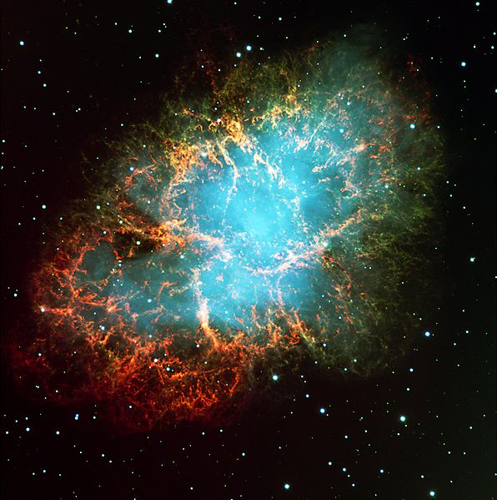
Question 19 (4 marks)
In 1054 AD Chinese astronomers noticed the appearance of a bright star visible in the constellation of Taurus. It was a supernova explosion – the death of a star. The Crab Nebula is the shattered remnant of that massive star. The nebula is about 6 500 light-years away from the Earth and is 5 light-years across, and has a pulsar (a rotating neutron star) at its centre.

- In which year (BC) did this supernova actually take place?(Show your working)

1054 – 6500 = - 5446

Explosion was in 5446 BC
(1 mark)

- What is the distance, in km, across this nebula? (2 marks)

5 ly x 365.25 x 24 x 3600 x 3 x 10⁵
(1 mark)
= 4.733 x 10¹³ km
(1 mark)

Question 20 (2 marks)
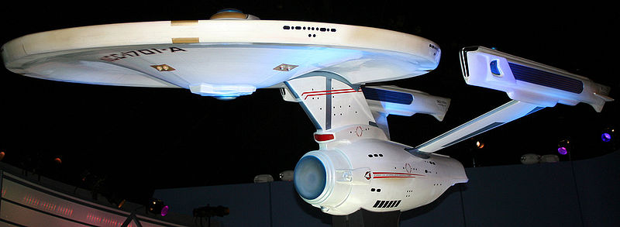
http://commons.wikimedia.org/wiki/File:Enterprise_NCC-1701-A.jpg

In the science fiction TV series Star Trek, the starship Enterprise is accelerated to speed faster than the speed of light (“warp speed”) for travel between star systems or galaxies. Explain why is it impossible to travel at or faster than the speed of light?

As the velocity of particles approach the speed of light, energy is required to increase the velocity further. Some of this energy is turned into mass requiring even larger amounts of energy to accelerate.
(1 mark)

No particle can reach the speed of light as it will gain mass according to the Einstein equation
E = mc².
(1 mark)

Question 21 (2 marks)
Two identical atomic clocks of extreme accuracy are set to within the same nanosecond at Greenwich in England. One of the clocks is then flown to Perth at 800 km h⁻¹. In Perth the clock is now several nanoseconds different to its “twin” still at Greenwich.

- Is the clock in Perth ahead or behind its “twin”? (1 mark)
Behind

- What has caused this difference in time? (1 mark)

According to Einstein’s theory of special relativity, time passage slows for a moving object.
(1 mark)

Question 22 (5 marks)
In the science fiction series Star Trek, Captain Kirk orders the starship Enterprise to travel from Earth on a rescue mission to Alpha Centauri (4.2 light-years away). Due to battle damage, the fastest speed that the Enterprise can travel at is just below the speed of light. The crew includes twins and while one of two identical twins is on the mission to Alpha Centauri the other remains on Earth.

- The Enterprise can only manage a speed of 0.98c (c = speed of light). At this speed, how long will the starship take to travel to Alpha Centauri and return as seen from Earth? (1 mark)

At 0.98c 8.4 ÷ 0.98 = 8.572 years

- The time dilation equation is
√
t .
v²

1 –
t₀ =
c²

where t₀ is the apparent time elapsed on the starship and t is the actual time taken for the trip.
For the crew on board, what appears to be the time taken to travel to Alpha Centauri and return? (2 marks)

t₀ = 8.572 √ 1 – (0.98c)²
c²
(1 mark)
= 1.706 years
(1 mark)

- On the return to Earth the twins are no longer the same age, one is older.
Which twin has aged more and by how much? (2 marks)

The Earth twin is older.
(1 mark)

The age difference is 8.572 – 1.706 = 6.866 years.
(1 mark)

Question 23 (7 marks)
The following graph shows the factor by which mass increases with increasing velocity approaching the speed of light.
Mass increase
v/c
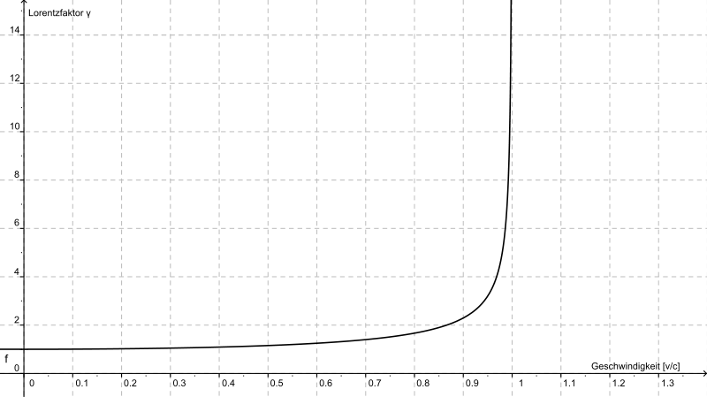
http://commons.wikimedia.org/wiki/File:Lorentzfaktor.svg

A proton of mass 1.67 x 10⁻²⁷ kg is accelerated in the Large Hadron Collider until it reaches 0.95c
(c = speed of light).

- Estimate the new mass of the proton from the graph. (2 marks)

From graph mass increases roughly by 3X
(1 mark)
1.67 x 10⁻²⁷ x 3 = 5.01 x 10⁻²⁷ kg
(1 mark)

- What is the reason for this apparent increase in mass? (1 mark)

Some of energy being put into proton to accelerate causes a mass increase E = mc².
(1 mark)

Einstein derived the mathematical equation showing how mass changes with speed.

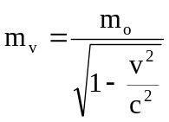

where m₀ is the rest mass and m_{v} is the mass when moving (in kg).

- Using the equation above, calculate the mass of the proton when it is moving at 0.99c.
(2 marks)

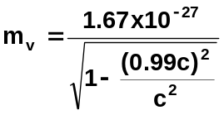 (1 mark)

= 1.67 x 10⁻²⁷
0.141

= 1.18 x 10⁻²⁶ kg or about a 7X increase.

- Why is it impossible for the proton to travel at or faster than the speed of light? (2 marks)
The proton cannot be accelerated to the speed of light its mass approaches infinity, this
would require and infinitely large force to accelerate the proton.

Question 24 (3 marks)
Adventure parks have developed rides that simulate the real adventure for their customers. Patrons sit in chairs in the dark and watch a projected computer image of a high speed chase. Every turn, dive and twist appears real as the seat appears to lurches, but in fact it is stationary. The virtual reality ride appears very realistic.

Why does it seem as if you are actually in a chase?
In the dark cannot see the other chairs. (1 mark)
The only frame of reference (1 mark)
is the screen which appears to be moving. (1 mark)

Question 25 (2 marks)
A freelance motoring journalist was caught speeding in a $470,000 imported Italian car at
231 km h⁻¹ during a test drive in a 110 km h⁻¹ zone.

- A police car coming in the opposite direction at 110 km h⁻¹ recorded his speed on its radar. What was the closing speed of the cars as they approached each other? (1 mark)

110 + 231 = 341 km h⁻¹

- If the police car was following the Italian car at 110 km h⁻¹, what speed would it register on the radar? (1 mark)

231 – 110 = 121 km h⁻¹

Question 26 (2 marks)
The Andromeda galaxy is receding from Earth at about 0.3c (c = speed of light).

In the search for extraterrestrial life, a radio signal is sent from Earth into space. At what speed is the radio signal received on Andromeda? Explain your answer.

Arrives traveling at 3 x 10⁸ m s⁻¹
(1 mark)
According to Einstein’s theory of special relativity the speed of light in a vacuum is constant no matter what is the frame of reference.

(1 mark)

Question 27 (3 marks)
In 1983, a Korean Airlines 747 airliner that strayed into Russian airspace (due to computer navigational errors) was shot down. Since 1994, 24 satellites in orbit have allowed positions on Earth to be accurately known to within 15 metres. Orbiting at an altitude of 20 200 kilometres, about 10 satellites are visible to the ground-based receiver. Each satellite continually transmits messages which include the time the message was sent. The receiver measures the time of each message from the satellites and computes the distance to each satellite.

To work correctly, the clocks on the satellites and the clock in the receiver must be set identically. The clocks are extremely accurate, relying on vibrating quartz crystals to keep the time. Over a period of exactly 24 hours the total time difference between the clock in the orbiting satellite and the clock in the GPS receiver is 3.8 x 10⁻⁵ s.

- What could cause the difference in time? (1 mark)
The clock on board the satellite is moving.

- Which clock runs faster? (1 mark)
Clock on Earth runs faster.

- What absolute error would there be in the measurement of the distance to a GPS receiver from a satellite directly overhead after 24 hours, if the clock is not corrected? (2 marks)

Error = 0.000038 x 3 x 10⁸ = 11400 m

Extension and Discussion questions

Question E1 (2 marks)
The Space Interferometry Mission (now called SIM Lite) is due to be launched by NASA in 2015. Operating in the visible waveband, SIM has the goal to measure stars’ parallax up to 4 micro-arcsecond with absolute precision. How many light-years away can it measure stars?

Use the formula d = 1 / p, where d = distance (in parsecs), p = parallax angle (in arcsec) and 1 parsec = 3.26156 light-years.

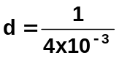 = 250 parsecs
(1 mark)
250 x 3.26156 = 815.39 light years
(1 mark)

Question E2 (5 marks)
Srain. ( 2006). Stellarparallax parsec1 [Diagram]. Retrieved October, 2009, from Wikimedia Commons website: http://commons.wikimedia.org/wiki/File:Stellarparallax_parsec1.svg

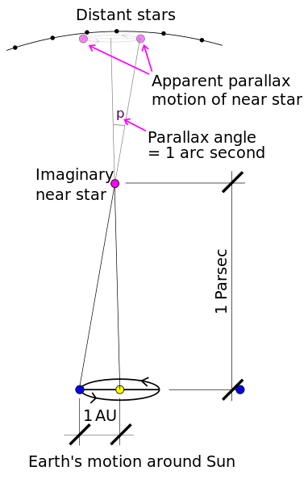
Before satellites were available, stellar parallax was measured from Earth using annual parallax as the Earth orbits around the sun.

(1 parsec = 3.26156 light-years and is also the distance for which the annual parallax is 1 arcsecond. 1 Earth year = 365.25 solar days)

- If the imaginary star in the diagram above is 1 parsec away, how distant is this star in metres?
(1 mark)
1 parsec = 3.26156 x 3 x 10⁸ x 365.25 x 24 x 3600 = 3.088 x 10¹⁶ m
(1 mark)

- Compass headings are given in degrees, minutes and seconds. What is one second as a decimal of a degree? (2 marks)

There are 60 seconds in 1minute and 60 minutes in a degree.
1 second = 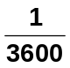 degree
(1 mark)

= 2.774 x 10⁻⁴ degrees
(1 mark)

- Calculate the radius of the Earth’s orbit around the sun in metres. (2 marks)

2.774 x 10⁻⁴

3.088 x 10¹⁶

x (1 mark)

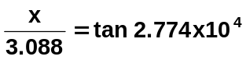 x = 1.497 x 10¹¹ m
(1 mark)

Question E3 (6 marks)
In 1989, the satellite Hipparcos was launched to measure the parallax of nearby stars. It measured the parallax of over 10 000 stars much more accurately than could be done by measurements on Earth. The data for three stars is given below.

Star | Parallax (milliarcseconds)
Sirrah, the brightest star in the constellation of Andromeda | 33.60 ± 0.73 mas
Polaris the north pole star | 7.56 ± 0.48 mas
Rigel the brightest star in the constellation Orion | 4.22 ± 0.81 mas

- Calculate the distance to each of these stars in light years and the absolute error. Use the equation d = 1 / p, where d = distance (in parsecs), p = parallax angle (in arcsec) (5 marks)

Sirrah 33.60 + 0.73 = 33.60 + 2.17%

1 = 29.76 + 2.17% pc x 3.26156 = 97 + 2.17%
33.60 + 2.17%
(1 mark)
= 97 + 2.1 ly
(1 mark)

Polaris 431 + 6.35% = 431 + 27.4 light-years
(1 mark)
Rigel 773 + 148 light-years
(1 mark)

- Suggest why the percentage error of each star’s distance measurement is increasing.
(1 mark)
For stars further away it is harder to measure parallax angles.

Question E4 (2 marks)
A student uses the parallax method to determine the distance to a tree about 2 km away. His experiment log shows the following drawing of his method.

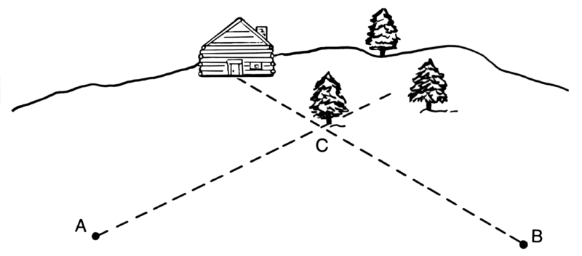
<---------- 20m --------->
Pearson Scott Foresman. (2008). Line art drawing of parallax [Diagram]. Retrieved October, 2009, from Wikimedia Commons website: http://upload.wikimedia.org/wikipedia/commons/c/cb/Parallax_%28PSF%29.png

The distance AB is accurately measured with a tape measure to be 20m.

How could this experiment be improved?

i Increase the length of the base line perhaps to 200 m
1 mark)
ii Increase the accuracy of the measurement of the angle.
(1 mark)

Question E5 (2 marks)
Lanoue, J. (2006). M31 Lanoue [Photograph]. Retrieved October, 2009, form Wikimedia Commons website: http://upload.wikimedia.org/wikipedia/commons/7/71/M31_Lanoue.png

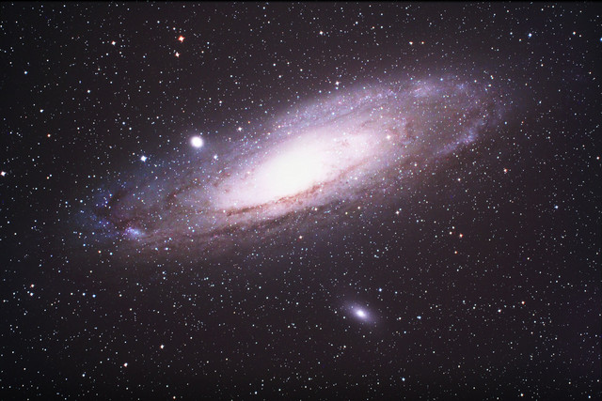
The redshift of the Andromeda galaxy has been calculated as 0.301.

A radio telescope monitoring H radio emission (normally at 21.106 cm) will need to monitor a different wavelength to pick up emissions from Andromeda.

Which wavelength must be monitored?

The following equation is used for calculating red shift, Z:
Z = λ_{obs} – λ_{rest}
λ_{rest}

0.301 = λ_{obs} - 21.106
21.106
(1 mark)
= 27.459 cm
(1 mark)

Question E6 (2 marks)
The end of the Universe is predicted by astronomers somewhere between 10¹⁴ and 10⁴⁰ years from now. Astronomers have two theories for the future of the Universe – the “open” and “closed” Universe. How do these two theories differ?

Closed universe—gravity will eventually slow the moving galaxies and then reverse their motion until they all come together again.
(1 mark)
Open universe—expansion continues until all energy is used up. No energy left means no heat.
(1 mark)

Question E7 (3 marks)
A Klingon battleship passes by the stationary starship Enterprise at 0.92c. To the crew on the Enterprise, the Klingon vessel appears

- longer/ shorter/ the same as its known length of 500m. (1 mark)

Using the equation
_______
L = L₀ √ 1 – v²
c²

where L is the observed length and L₀ is the actual length
shorter
- calculate the length of the Klingon battleship as it appears to the crew on the Enterprise.
(2 marks)

_______
L = L₀ √ 1 – v²
c²
where L is the observed length and L₀ is the actual length,

calculate the length of the Klingon battleship as it appears to the crew on the Enterprise.
_______
L = L₀ √ 1 – v²
c²
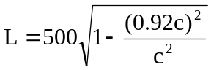
(1 mark)
= 500 x 0.3919
= 195.9 m
(1 mark)

Question E8 (7 marks)
Muons are formed when cosmic radiation impacts air molecules 10 km up in the Earth’s atmosphere. About 10 000 muons reach every square meter of the Earth’s surface every minute. The mean lifetime of a stationary muon is 2.2 x 10⁻⁶ seconds before it decays. Muons travel at speeds of up to 0.999c and can penetrate deep into rock. They are detectable deep underground and underwater.

Rossi and Hall in 1940 were able to “prove” the effect of time dilation on high speed muons. They measured muon impacts on a scintillation counter at an altitude of 3000 metres (568 counts h⁻¹) and at sea level (412 counts h⁻¹).

- What distance would a muon be expected to travel in its mean lifetime? (Not including any special relativity effects) (1 mark)

s = v x t
= 2.2 x 10⁻⁶ x 0.999 x 3 x 10⁸
= 660 m
(1 mark)

- Using the information from (a) would you expect many muons to reach the Earth’s surface from where they were formed? (1 mark)

If the average muon only travels 660 m then few will travel from the upper atmosphere to the Earth’s surface.

- Using the equation below, calculate the mean lifetime of a muon in its own (moving) frame of reference. (2 marks)
_______
t₀ = t. √ 1 – v²
c² where t₀ is the actual time and t is the apparent time.

2.2 x 10⁻⁶ = t . √ 1 – (0.999c)²
c²
(1 mark)

t = 4.92 x 10⁻⁵ seconds is mean lifetime as seen by the muon itself.
(1 mark)

- How far will a muon move in its mean lifetime taking into account special relativity? (1 mark)

s = v x t
= 0.999 x 3 x 10⁸ x 4.92 x 10⁻⁵
= 14745 m
(1 mark)

- Would you now expect more muons to reach the Earth’s surface? Explain. (1 mark)

Say from 3000 m where there are considerable muons – yes.

- How did the data collected by Hall and Rossi “prove” time dilation actually exists? (1 mark)

Muons “live” longer and this explains why they are recorded deep below ground.

